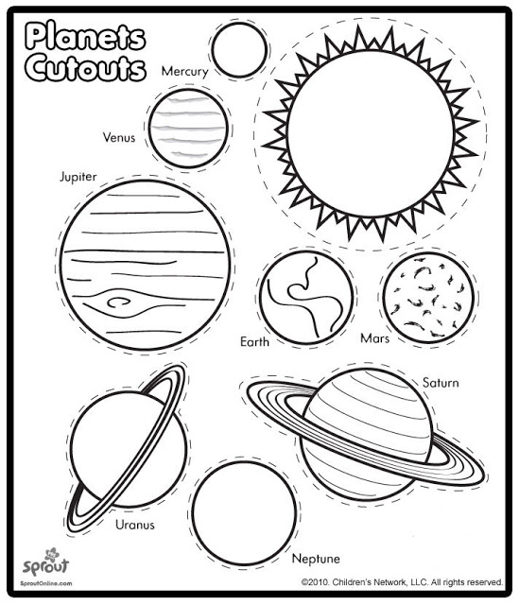

Solar System to Scale
Step 1- Color all of the planets.
Step 2- Cut out a length of paper 210 cm long.
Step3- Cut out all of the planets.
Step 4- Glue the planets the correct distance from the start of the paper. The asteroid belt will need to be drawn.
Step 5- Make sure all the planets are labeled and that your name is written on the paper somewhere.
Object | Centimeters from the start
Sun | 3.5
Mercury | 10
Venus | 12.2
Earth | 16
Mars | 22
Asteroid Belt | 26.6
Jupiter | 43
Saturn | 67.5
Uranus | 120
Neptune | 206

