Solar System Drawing
Draw all planets, moons and orbits.
Title the page “The Solar System”.
Color Everything!
Make sure that the following objects are all on your drawing.
- Sun
- Mercury
- Venus
- Earth
- The Moon
- Mars
- Phobos
- Deimos
- The Asteroid Belt
- Ceres
- Jupiter
- Io
- Callisto
- Ganymede
- Europa
- Saturn
- Titan
- Uranus
- Epsilon
- Umbriel
- Neptune
- Triton
- Pluto
- Charon
- Kuiper Belt
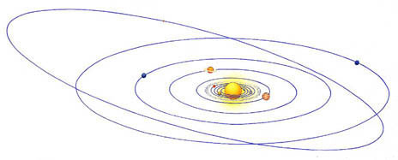

Solar System Drawing
Draw all planets, moons and orbits.
Title the page “The Solar System”.
Color Everything!
Make sure that the following objects are all on your drawing.
- Sun
- Mercury
- Venus
- Earth
- The Moon
- Mars
- Phobos
- Deimos
- The Asteroid Belt
- Ceres
- Jupiter
- Io
- Callisto
- Ganymede
- Europa
- Saturn
- Titan
- Uranus
- Epsilon
- Umbriel
- Neptune
- Triton
- Pluto
- Charon
- Kuiper Belt

Solar System Drawing
Draw all planets, moons and orbits.
Title the page “The Solar System”.
Color Everything!
Make sure that the following objects are all on your drawing.
- Sun
- Mercury
- Venus
- Earth
- The Moon
- Mars
- Phobos
- Deimos
- The Asteroid Belt
- Ceres
- Jupiter
- Io
- Callisto
- Ganymede
- Europa
- Saturn
- Titan
- Uranus
- Epsilon
- Umbriel
- Neptune
- Triton
- Pluto
- Charon
- Kuiper Belt

